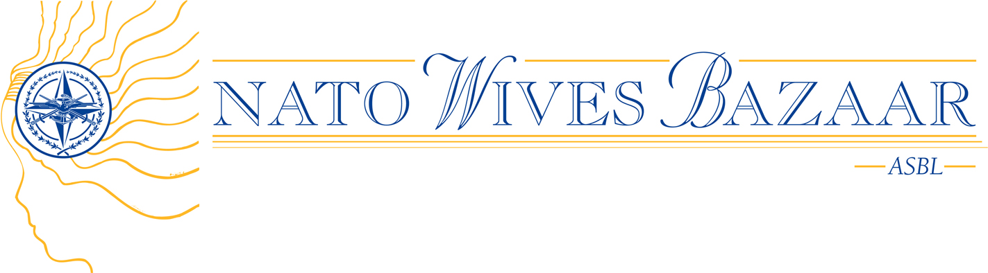
Pre-Selected Charities for 2009

Belgian Charities

- HAVENZATE
- LES MAINS OUVERTES POUR HAITI
- EFFATA
- ECOLE DU CBIMC
- UN METIER POUR TOUS
- JEST FARILU
- ECOLE “LES COCCINELLES”
- KINDERDAGVERBLIJFJE DE STEIJGERTJES
- LE CREUSET
- LIDWINA VOOR MS
- DIENSTENCENTRUM TER DREVE
- EINDELIJK
- LA PREUVE PAR TROIS
- ENTRAIDE FRANÇAISE
- AVEGA AGAHOZO
- OPSTAP
- CENTRUM GANSPOEL
- CONVIVIUM

International Charities

- MAMU UNIJA (Lithuania)
- CHILDREN’S CENTER VESKÁ (Czech Republic)
- LIGHT OF MY EYES FOR SICK CHILDREN (Hungary)
- WOMEN FOR WOMEN (Rwanda)
- HACO (Haiti)
- PRIATELIA SLANÝCH DETÍ (Slovakia)
- ÉCOLE PRIMAIRE BUKINJE (Bosnia)
- MOLITA BITOLA (the former Yugoslav Republic of Macedonia¹)
- FUNDATIA RAINBOW (Romania)
- PNEUMOFTIZIOLOGY HOSPITAL FROM ORADEA (Romania)
- CENTER FOR TRAINING ELVIRA VATOVEC STRUNJAN (Slovenia)
- DON BOSCO ASSOCIATION (Togo)
- HOUSE OF RUGUTE (Lithuania)
- ROKAIZOS (Latvia)
- FATHER KLAAS SCHILDER FOUNDATION (Congo)
- NOVÝ DOMV (Slovakia)
- PRO CEFA (Romania)
- AFEDI (Congo)
- EMBERÉLET FOUNDATION (Hungary)
- CARE HOME FOR PEOPLE WITH AUTISM (Hungary)
- CIUDAD SAN JUAN DE DIOS (Spain)
- L’ARCA DEL SEPRIO (Italy)
- PASFA (Lebanon)
- L’AQUILA AIL (Italy)

(¹) Turkey recognizes the Republic of Macedonia with its constitutional name

